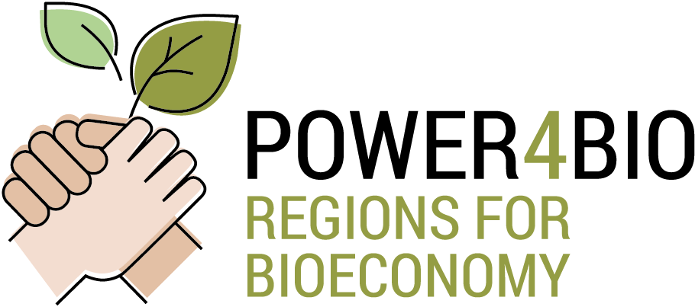

Agenda
Meeting: II General Assembly & III Steering Committee
Date: 19 February 2020
Venue: Arenberg Building, Room: TBC - Rue d'Arenberg 9, 1000 Brussels (Belgium).

Schedule:
Item | Time | Subject | Speaker
1 | 09.30 | Welcome and Introduction | ALL
2 | 09.40 | Project Overview (15 min) | CIRCE
3 | 09.55 | WP1 (15 min) | CIRCE
4 | 10.10 | WP2 (15 min)  - Task 2.4 status and planning | CIRCE, DRAXIS
5 | 10.25 | WP3 (20 min)  - Results from D3.3 submitted in m15  - Summary and status of D3.4 due in m17 | WR  CIRCE
 | 10.45 | Coffee break
6 | 11.05 | WP4 (60 min)  - Summary and status of D4.1 due in m17  - Task 4.2 status and planning  - Task 4.3 status and planning  - Task 4.4 status and planning | BZN  WR  META  META
7 | 12.05 | WP5 (45 min)  - Results from D5.2 submitted in m16  - Task 5.3 status and planning  - Task 5.4 status and planning | CIRCE  DBFZ  DBFZ
 | 12.50 | Lunch break
8 | 14.00 | WP6 (45 min)  - Task 6.1 status and planning  - Task 6.2 status and planning  - Task 6.3 status and planning | AKI  AKI  CIRCE
9 | 14.45 | WP7 (45 min)  - Tasks 7.1, 7.2, 7.3, 7.4 status and planning. | EPC, AKI
 | 15.30 | Coffee break
10 | 15.45 | Discussion, Wrap up and next steps | ALL
11 | 16:15 | Work sessions (to be confirmed in the final version of the agenda according to tasks needs. Partners are requested to inform CIRCE if any work session is necessary, indicating task, duration and partners involved)
12 | 18.00 | End of meting
 | xx.xx | Social dinner (time and restaurant to be confirmed)

Attendees: (to be confirmed)
Confirm participation in this form https://docs.google.com/spreadsheets/d/1pHh9-Pe644FJUtIrTi5tf8BKspJsg7N0ce4d1J0M93M/edit?usp=sharing
Name | Entity
Ignacio Martín | 1. CIRCE - Fundación CIRCE | ES
María Izquierdo | 1. CIRCE - Fundación CIRCE | ES
 | 1. CIRCE - Fundación CIRCE | ES
 | 1. CIRCE - Fundación CIRCE | ES
 | 2. DBFZ - Deutsches Biomasseforschungszentrum Gemeinnuetzige GMBH | DE
 | 2. DBFZ - Deutsches Biomasseforschungszentrum Gemeinnuetzige GMBH | DE
 | 2. DBFZ - Deutsches Biomasseforschungszentrum Gemeinnuetzige GMBH | DE
 | 3. WR - STICHTING WAGENINGEN RESEARCH | NL
 | 3. WR - STICHTING WAGENINGEN RESEARCH | NL
 | 4. META - META GROUP SRL | IT
 | 4. META - META GROUP SRL | IT
 | 5. AKI - AGRARGAZDASAGI KUTATO INTEZET | HU
 | 5. AKI - AGRARGAZDASAGI KUTATO INTEZET | HU
 | 6. EPC- EPC PROJEKTGESELLSCHAFT FÜR KLIMA | DE
 | 6. EPC- EPC PROJEKTGESELLSCHAFT FÜR KLIMA | DE
 | 7. DRAXIS - DRAXIS ENVIRONMENTAL S.A. | EL
 | 8. BZN - BAY ZOLTAN ALKALMAZOTT KUTATASI KOZHASZNU NONPROFIT KFT | HU
 | 8. BZN - BAY ZOLTAN ALKALMAZOTT KUTATASI KOZHASZNU NONPROFIT KFT | HU
 | 8. BZN - BAY ZOLTAN ALKALMAZOTT KUTATASI KOZHASZNU NONPROFIT KFT | HU
 | 9. UNFU - Ukrainian National Forestry University | UA
 | 10. CAPDER - CONSEJERIA DE AGRICULTURA, PESCA Y DESARROLLO RURAL | ES
 | 10. CAPDER - CONSEJERIA DE AGRICULTURA, PESCA Y DESARROLLO RURAL | ES
 | 11. MAE - MAZOWIECKA AGENCJA ENERGETYCZNA SPZOO | PL
 | 11. MAE - MAZOWIECKA AGENCJA ENERGETYCZNA SPZOO | PL
 | 12. USB - JIHOCESKA UNIVERZITA V CESKYCH BUDEJOVICICH University of South Bohemia | CZ
 | 12. USB - JIHOCESKA UNIVERZITA V CESKYCH BUDEJOVICICH University of South Bohemia | CZ
 | 13. CCB - CHEMIE CLUSTER BAYERN GMBH | DE
 | 14. SPRING- Sustainable Processes and Res. for Innovation and National Growth | IT
 | 15. EWI - VLAAMS GEWEST | BE
 | 15. EWI - VLAAMS GEWEST | BE
 | 16. SUA - SUA SLOVENSKA POLNOHOSPODARSKA UNIVERZITA V NITRE | SK
 | 16. SUA - SUA SLOVENSKA POLNOHOSPODARSKA UNIVERZITA V NITRE | SK
 | 17. ECRN - European Chemical Regions Network (ECRN) e.V. | DE

