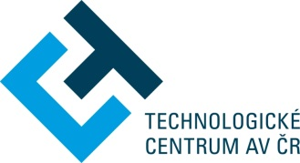

Technology Centre CAS
takes the pleasure to invite you to

Bio-based Industries JU 2019 call
National Infoday

Date of event: 25 April 2019 10.00-14.00
Venue: Technology Centre CAS, Ve Struhách 27, Praha 6

The event will inform about the activities of the BBI Joint Undertaking and their impact, the topics of the 2019 call, results of the previous calls, as well as present successful international projects and bio-economy initiatives at national level.

Program
9.30 – 10.00 Registration
10.00 – 10.10 Welcome address
Naďa Koníčková, Technology Centre CAS
10.10 – 10.35 Current BBI JU 2019 Call and Impact of the BBI Initiative
Antonella Canalis, BBI JU project officer
10.35 – 10.50 Overview of BBI JU calls and results of the 2018 call
Petr Pracna, Technology Centre CAS
10.50 – 11.05 Information from the BBI JU States Representatives Group
David Kubička, VŠCHT, VTP Kralupy
11.05 – 11.30 Coffee break
11.30 – 11.50 Presentation of the Power4Bio project
Eva Cudlínová, University of South Bohemia
11.50 – 12.10 Results of the DanuBioValNet project
Pavla Břusková, National Cluster Association
12.10 – 12.25 The BioEast initiative
Iva Blažková, Czech Ministry of Agriculture
12.25 – 12.40 Bio-economy Platform of the Czech Republic
Miroslav Hájek, Czech University of Life Sciences Prague
12.40 – 13.00 Bio-economy education programs
Eva Cudlínová, University of South Bohemia
13.00 – 14.00 Lunch and informal networking

Registration is open till 22 April 2019 or reaching the venue capacity at http://geform.tc.cz/infodenBBI2019 and will be confirmed by an email reply. Presentations will be given in English. Participation is free of charge, the event is supported by the project CZERA3 (LTI 18020) funded by the Ministry of Educatíon, Youth and Sports.

